

**SWE30010 - Managing IT Projects**

**TASK 11: Sprint 1 End-of-Sprint Progress Reporting**

HUMAN RESOURCE MANAGEMENT WITH

ATTENDANCE SYSTEM

*Group 2*

**GROUP 2 INFORMATION**

| **Name** | **ID** | **Tutor** | **Class** |
| --- | --- | --- | --- |
| Le Hoang Hai | 103542974 | Thomas Hang  Nsam@swin.edu.au | Saturday  7:00 AM |
| Nguyen Dinh Nhat Minh | 103802490 |
| Nguyen Nhat Huy | 103802911 |
| Nguyen Ngoc Minh Thy | 103802791 |

**SPRINT TASK**

1. **Introduction**

This task is concerned with developing the HRM Application project for Gemadept. This task specifically is going to be a continuation from the previous task of keeping track of day 1 to 5’s progress as it is about the progress of day 6 to 10.

For the main content, we will attempt to deliver the manager’s portal and then database design and management. These items are not previously done in the last task due to time constraints, however they will be developed here.

1. **Task progress**
2. **Day 6**

**Tasks Sign Up**

| **Item** | **Description** | **Member** |
| --- | --- | --- |
| Identify and prioritise the key entities in the HR domain. | These entities include employee’s name, departments, positions, and additional entities like salaries, and performance reviews. By prioritising these entities, we can ensure that we stay focused on the most critical aspects of HR management that directly impact organisational operations and goals. | Hoang Hai  Nhat Minh |
| Define the attributes and data types for each entity based on the information to be stored. | We will carefully analyse the information to be stored for each entity and determine the appropriate data types, such as string, integer, date, decimal, etc., to accurately capture and represent the data. | Hoang Hai  Nhat Minh |
| Create an ERD to visualise the relationships between different entities. | By creating an ERD, we should have a better understanding of the structure and interactions between HR entities, which will help form effective database design and system development. | Hoang Hai  Nhat Minh  Nhat Huy |

**Trello task board update**

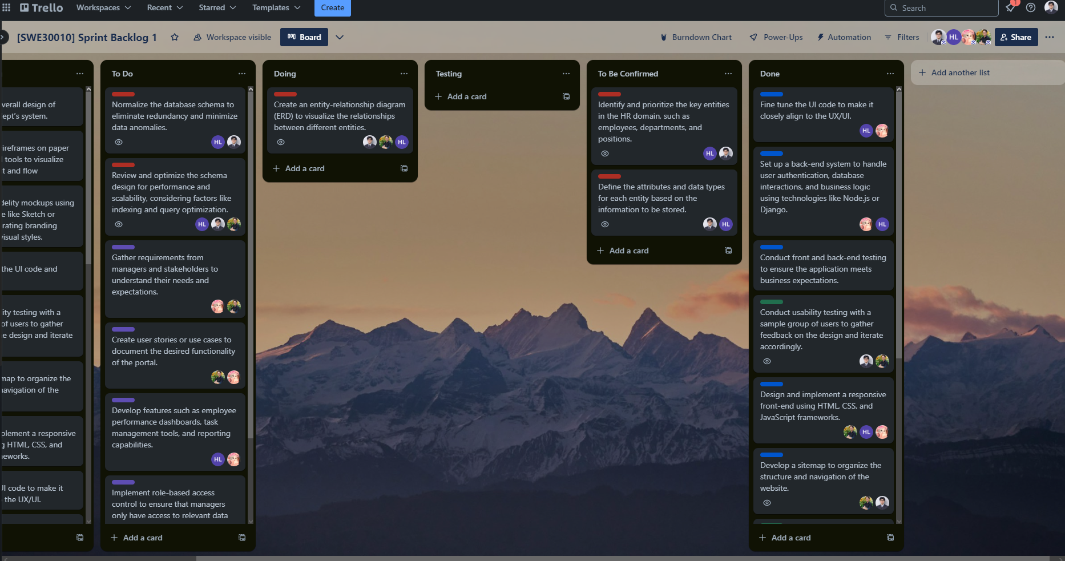

**Github repository**

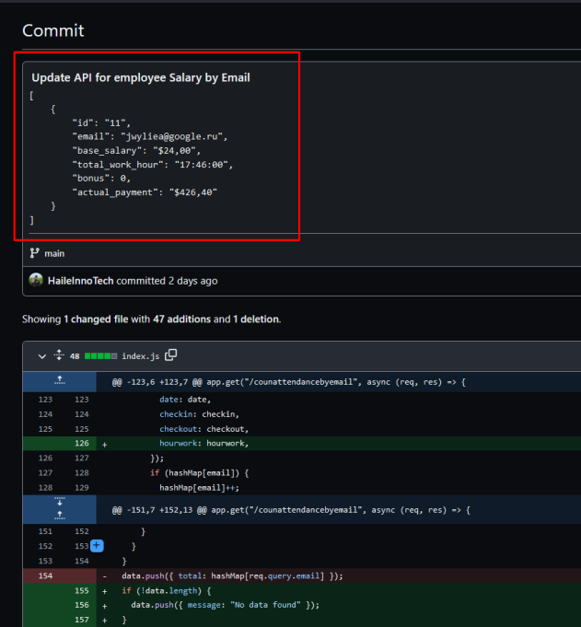

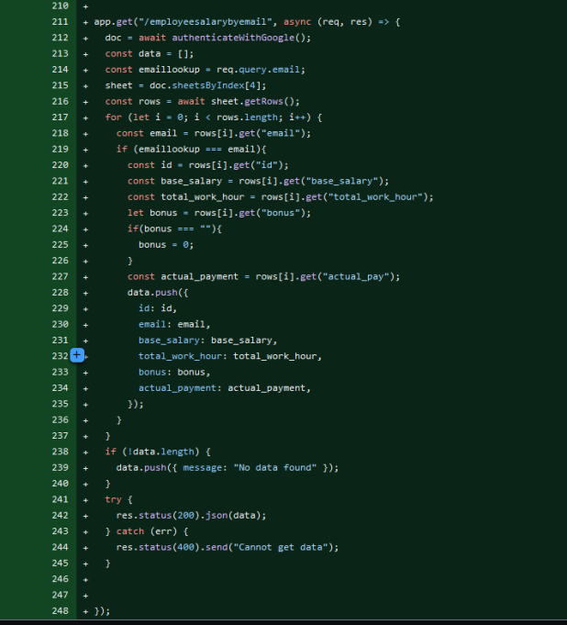

**Burndown chart**

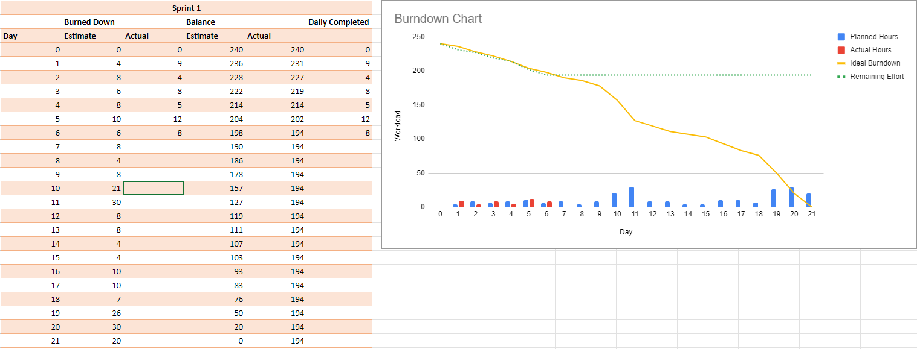

**Daily meeting minute**

| **Status** | **Description** | **Count** |
| --- | --- | --- |
| Item Done | N/A | 0/3 |
| Item Testing | N/A | 0/3 |
| Item Confirming | Identify and define the attributes and data types for each HRM entity based on the information to be stored. | 2/3 |
| Item Not Done | ERD Creation, this task takes a long time as ERD designers need to take a lot of consideration into account to create a good model. | 1/3 |
| Next step | Review the initial version of the ERD, import some employee data and perform normalisation on it |  |

1. **Day 7**

**Tasks Sign Up**

| **Item** | **Description** | **Member** |
| --- | --- | --- |
| Review of ERD. | Make sure the first database design is adequate, this step can take some time as the reviewer must ensure correct association between entities. | Nhat Minh  Nhat Huy  Hoang Hai |
| Normalize the database schema. | We identify entities, define attributes, establish primary keys, and apply normalization rules to ensure data integrity and optimize performance to organise a database schema to eliminate redundancy and minimize data anomalies. | Hoang Hai  Nhat Minh |
| Review and optimize the schema design. | Our team optimises the query statements and or the apis code to make sure the website can function as optimised as possible, i.e., faster and more reliable. | Nhat Minh  Nhat Huy  Hoang Hai |

**Trello task board update**

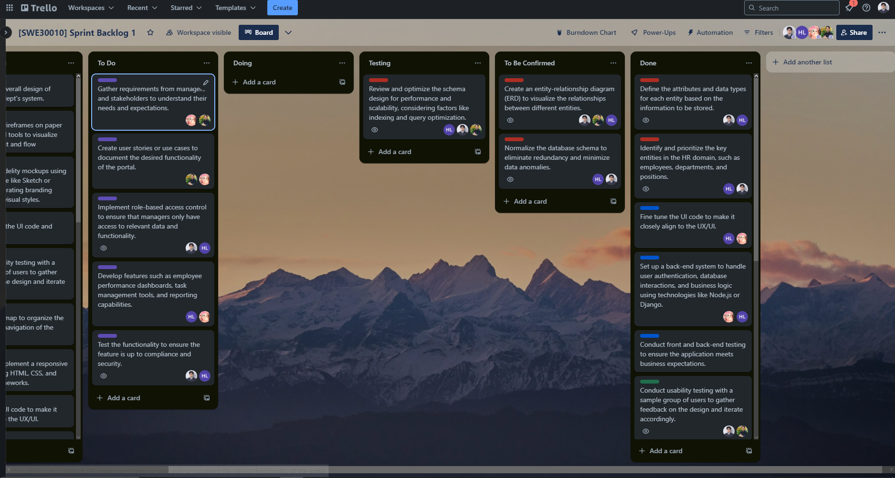

**Github repository**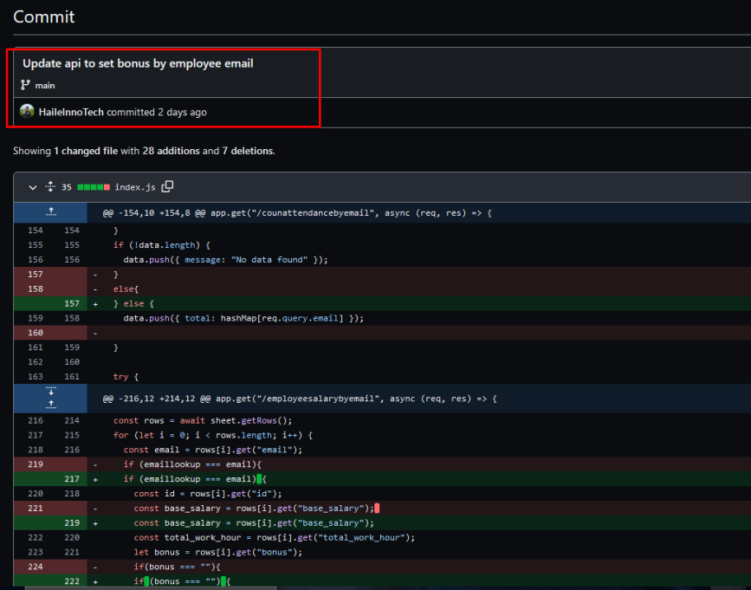

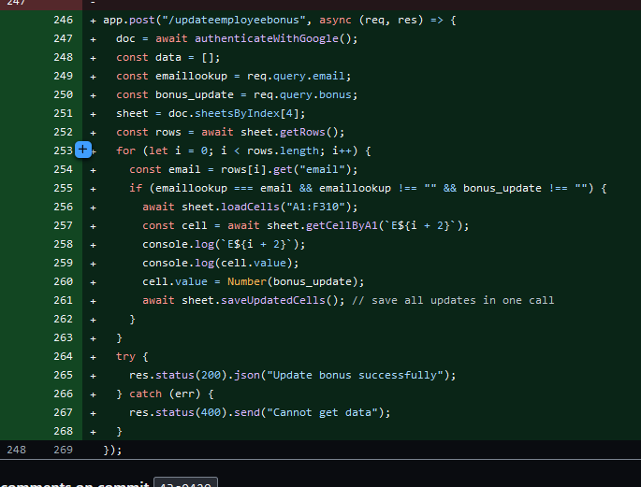

**Burndown chart**

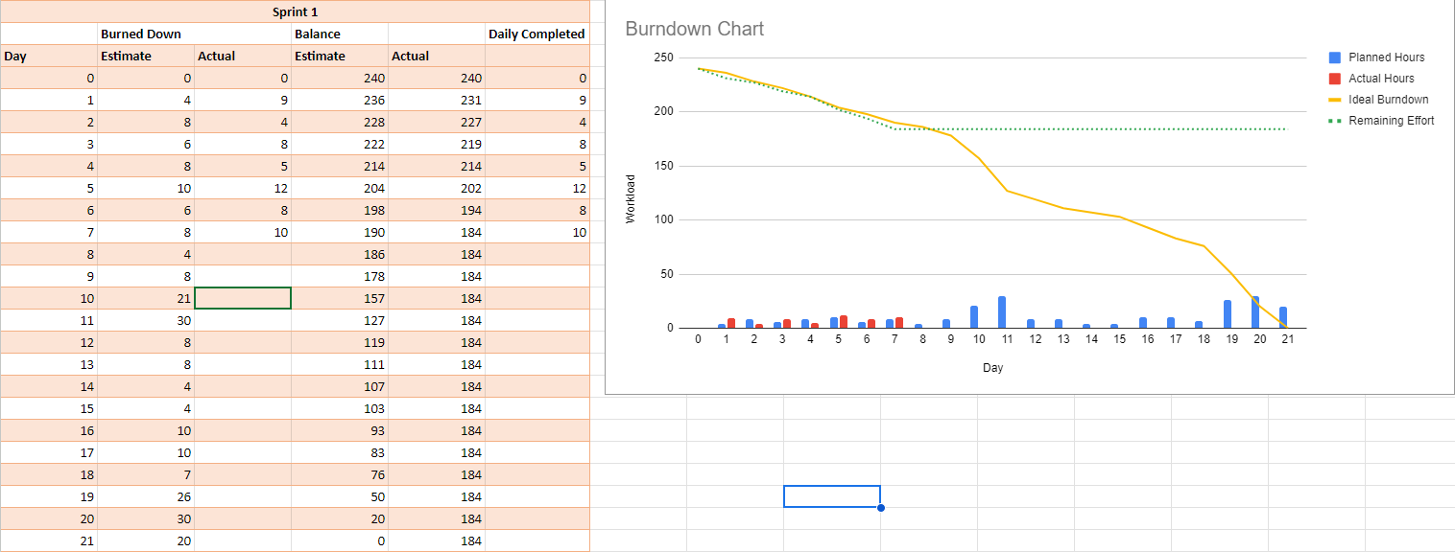

**Daily meeting minute**

| **Status** | **Description** | **Count** |
| --- | --- | --- |
| Item Done | Identify and define HRM attributes to use in the database design | 2/5 |
| Item Testing | Review and optimize the schema design. | 1/5 |
| Item Confirming | Create an entity-relationship diagram (ERD).  Normalize the database schema. | 2/5 |
| Item Not Done | N/A | 0/5 |
| Next step | Finish nomarlizing and optimizing the database as well as its relevant code. Start collecting insight to build the Manager Portal. |  |

1. **Day 8**

**Tasks Sign Up**

| **Item** | **Description** | **Member** |
| --- | --- | --- |
| Finish the ERD schema | Continue working on the ERD to finalise it | Nhat Minh  Nhat Huy  Hoang Hai |
| Normalize the data in the database | Continue with cleaning and normalizing the data within the database for better consistency between functions | Nhat Minh  Hoang Hai |
| Review and optimize the schema design. | We review the task at the end to make sure it functions well (those who did not do the coding well review the code, while the one to code will review the schema design). | Nhat Minh  Nhat Huy  Hoang Hai |
| Gather requirements from managers and stakeholders. | Our team will engage with managers and stakeholders to gather comprehensive requirements for the portal. As we need to ensure that the portal meets their specific requirements and delivers value to the users. | Nhat Huy  Minh Thy |
| Create user stories or use cases to document the desired functionality of the portal. | We will review the requirements from managers and stakeholders then document the desired functionality of the portal through user stories or use cases. This will help us capture the requirements in a clear and structured manner, allowing for better communication and alignment between the development team and stakeholders. | Nhat Huy  Minh Thy |

**Trello task board update**

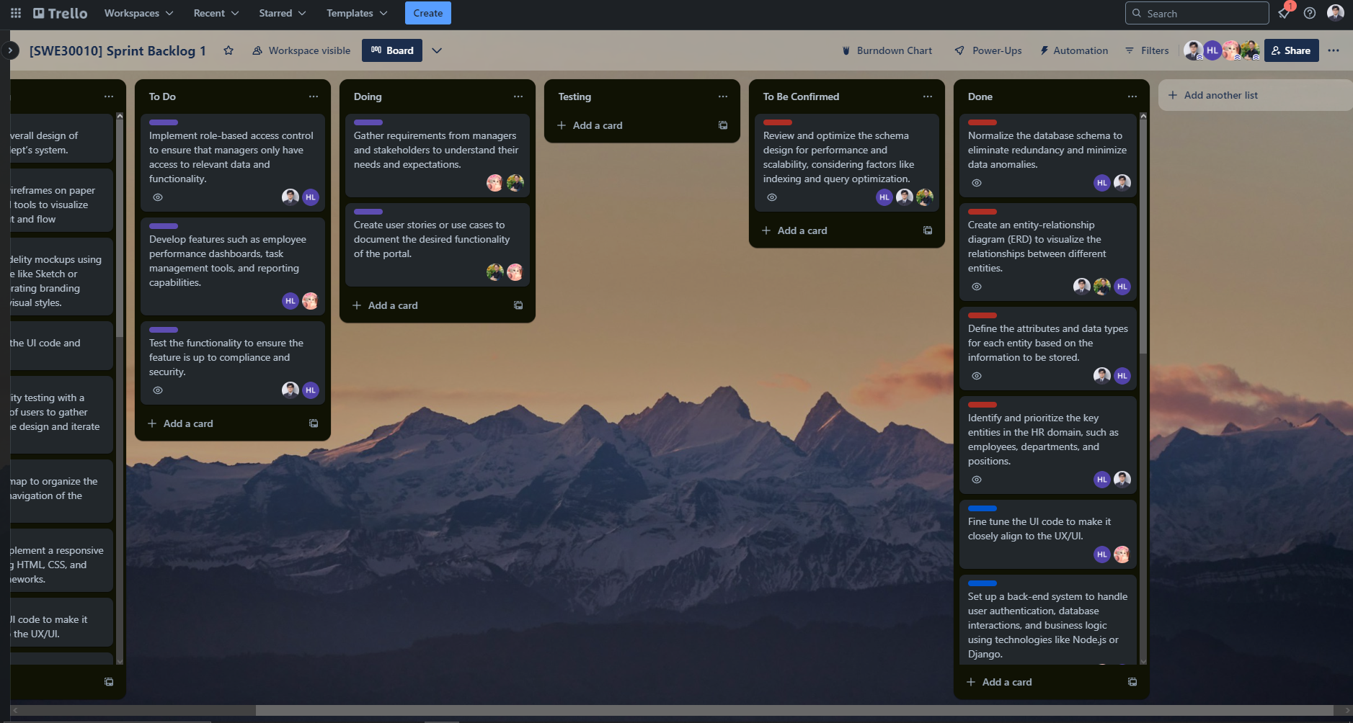

**Github repository**

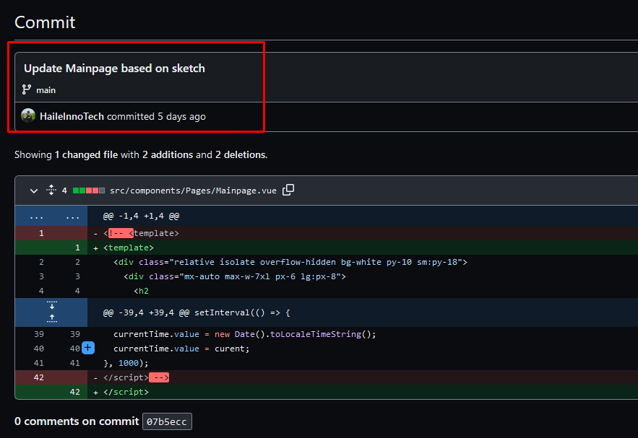

**Burndown chart**

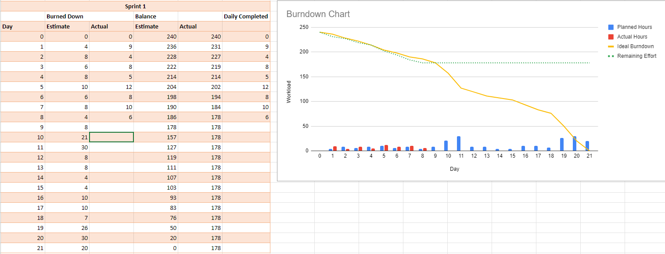

**Daily meeting minute**

| **Status** | **Description** | **Count** |
| --- | --- | --- |
| Item Done | Create and normalize the schema as well as the database. | 2/5 |
| Item Testing | N/A | 0/5 |
| Item Confirming | Review and optimize the schema design, basically fine tuning schema for better performance | 1/5 |
| Item Not Done | Gather requirements from managers and stakeholders.  Create user stories or use cases to document the desired functionality of the portal. | 2/5 |
| Next step | As gathering requirements and creating user stories goes together, these tasks need to be done with one another, hence we need to finish them together next time. |  |

1. **Day 9**

**Tasks Sign Up**

| **Item** | **Description** | **Member** |
| --- | --- | --- |
| Finish documenting and getting user’s requirement | In order to develop the functions, we need this task to be done first. | Minh Thy  Nhat Huy |
| Develop features such as employee performance dashboards, task management tools, and reporting capabilities. | These features will allow users to track performance metrics, manage their attendance, and generate insightful reports to support decision-making processes. We aim to enhance productivity and enable data-driven decision-making within the organization with the development of these functionalities. | Hoang Hai  Minh Thy |
| Implement role-based access control to ensure that managers only have access to relevant data and functionality. | We perform this task as to ensure that only authorized managers have access to relevant information based on their roles and responsibilities, thereby enhancing data security and confidentiality. | Nhat Minh  Hoang Hai |
| Test the functionality to ensure the feature is up to compliance and security. | Our team will test the functionality of the system to ensure it complies with regulatory requirements and adheres to security standards. | Nhat Minh  Hoang Hai |

**Trello task board update**

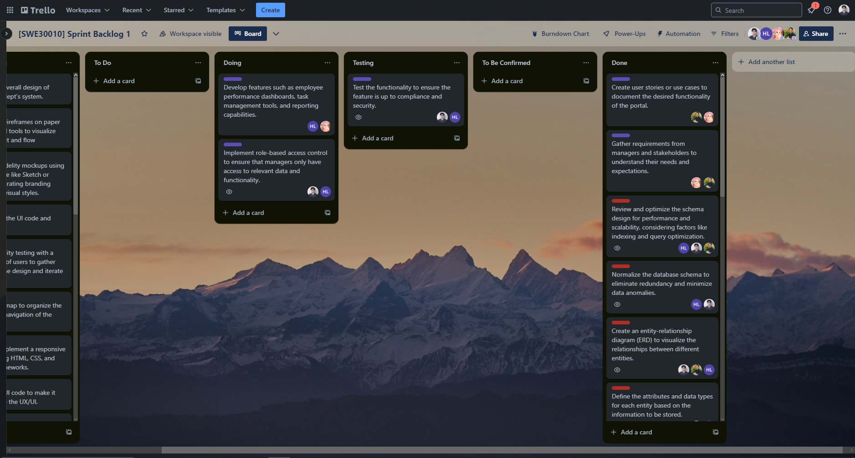

**Github repository**

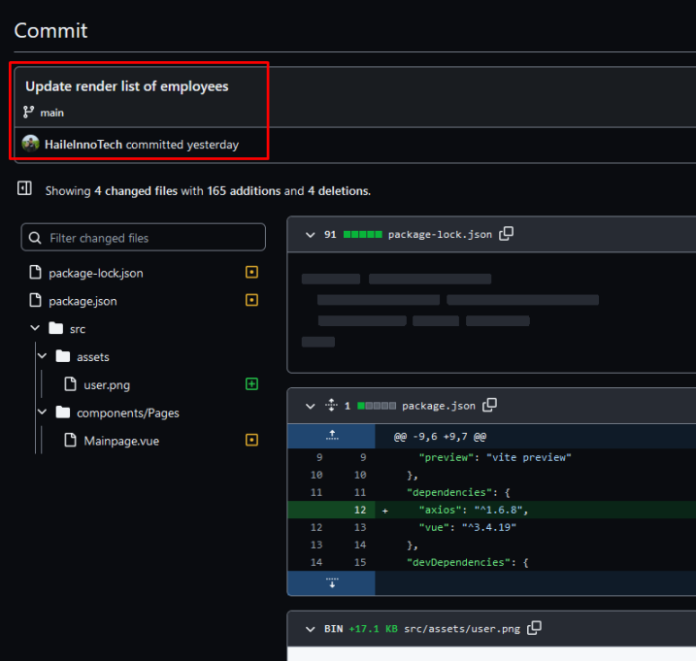

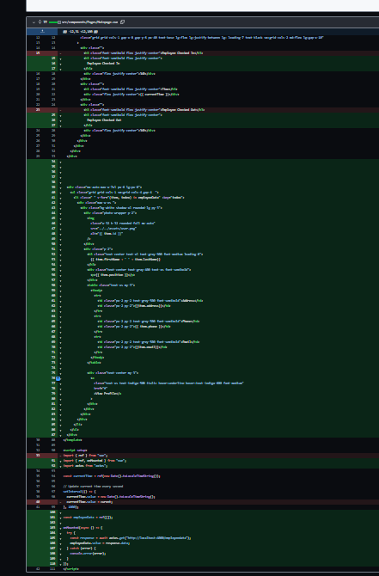

**Burndown chart**

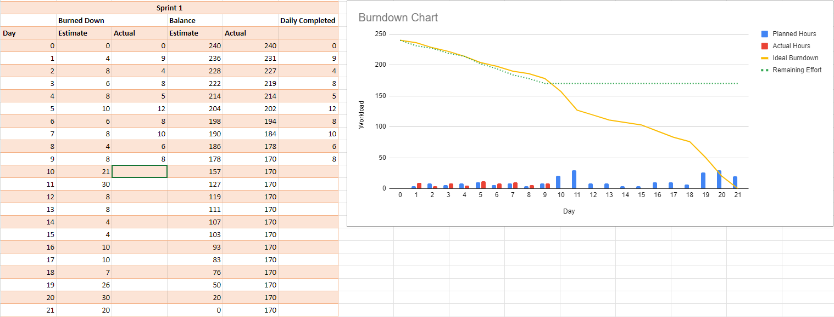

**Daily meeting minute**

| **Status** | **Description** | **Count** |
| --- | --- | --- |
| Item Done | Documenting users requirements | 1/4 |
| Item Testing | Test the functionality to ensure the feature is up to compliance and security. | 1/4 |
| Item Confirming | N/A | 0/4 |
| Item Not Done | Implement role-based access control to ensure that managers only have access to relevant data and functionality.  Develop features such as employee performance dashboards, task management tools, and reporting capabilities. | 2/4 |
| Next step | Finish the website’s functions, review testing result and website’s security |  |

1. **Day 10**

**Tasks Sign Up**

| **Item** | **Description** | **Member** |
| --- | --- | --- |
| Finish development of manager’s functions | We need to ensure the functional aspect of the website to be developed before delivering it to the stakeholders, hence we need to make sure functions are completed | Hoang Hai  Minh Thy |
| Test the functionality to ensure the feature is up to compliance and security. | Testing must be done to ensure functional correctness of the product. | Nhat Minh  Hoang Hai |
| Implement role-based access control to ensure that managers only have access to relevant data and functionality. | Only Managers should have access to the Manager’s portal and other unauthorised access should be limited to ensure data security and privacy. | Nhat Minh  Hoang Hai |

**Trello task board update**

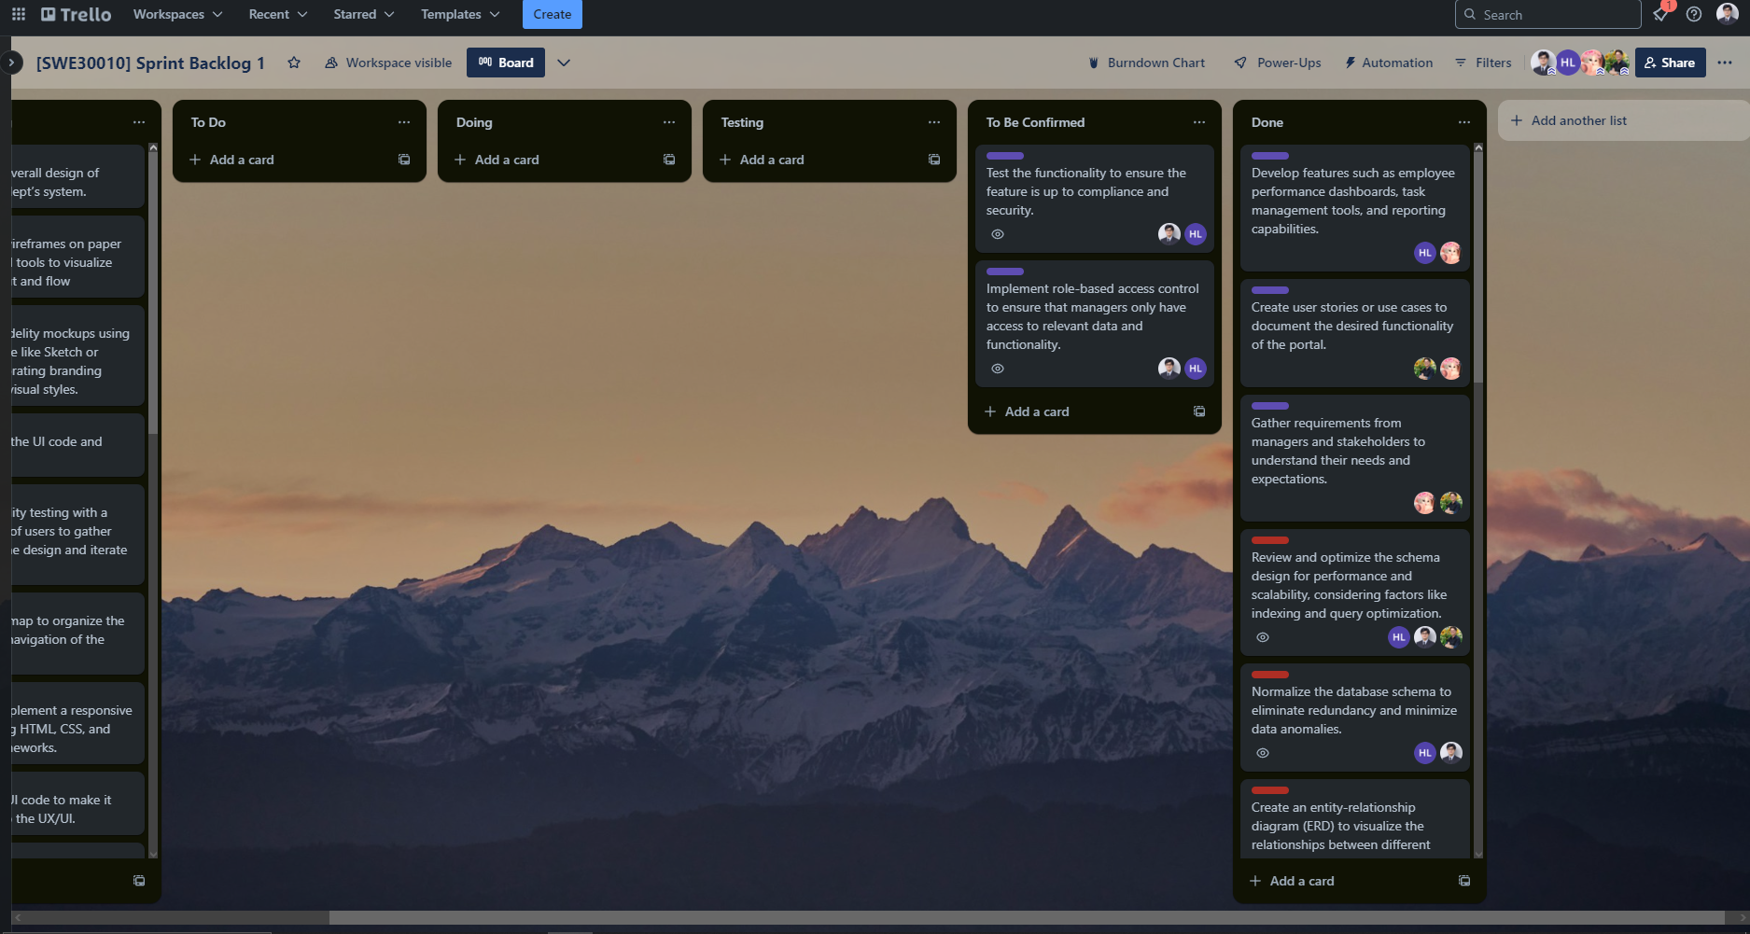

**Github repository**

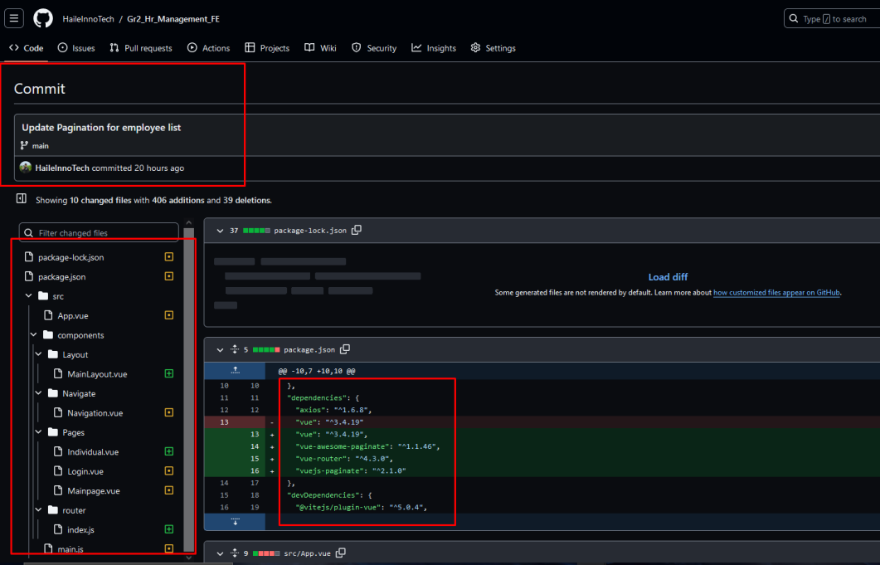

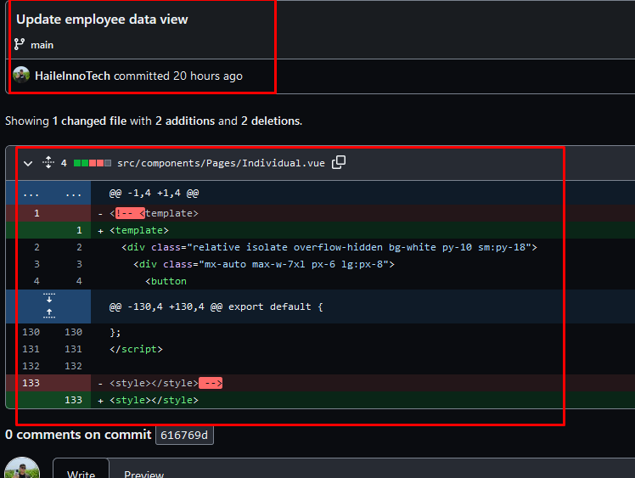

**Burndown chart**

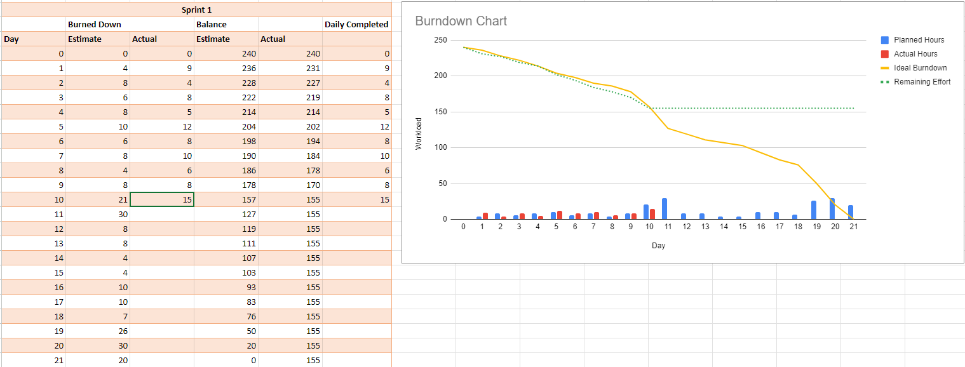

**Daily meeting minute**

| **Status** | **Description** | **Count** |
| --- | --- | --- |
| Item Done | Develop features such as employee performance dashboards, task management tools, and reporting capabilities | 1/3 |
| Item Testing | N/A | 0/3 |
| Item Confirming | Test the functionality to ensure the feature is up to compliance and security.  Implement role-based access control to ensure that managers only have access to relevant data and functionality. | 2/3 |
| Item Not Done | N/A |  |
| Next step |  |  |

**APPENDIX**

**HRM website’s ERD**

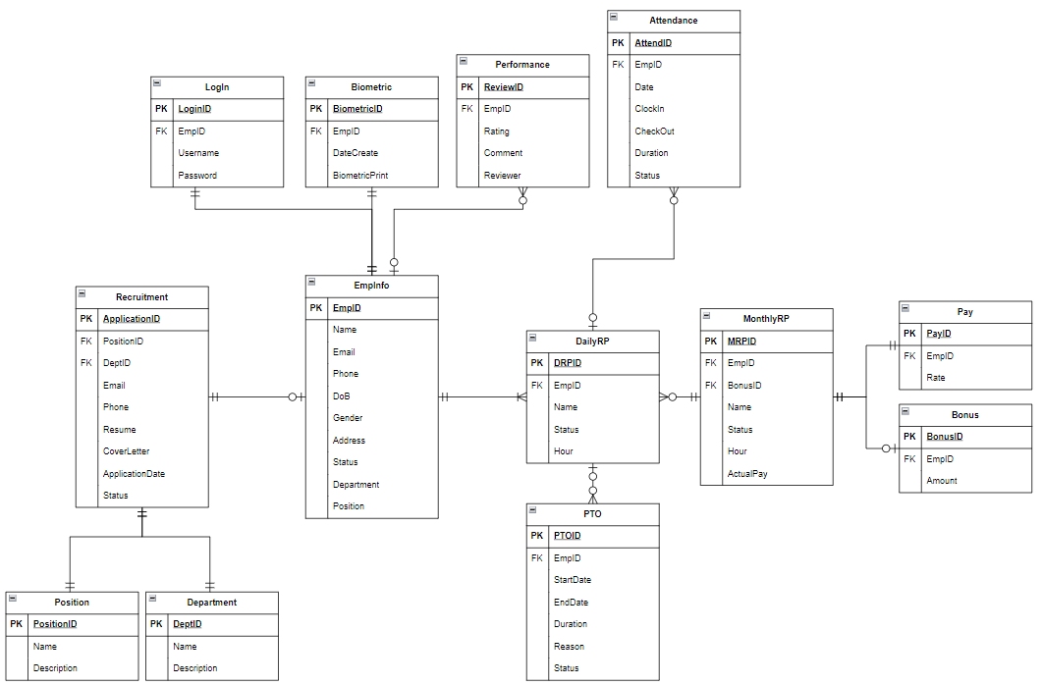

*Desired Database Design for HRM system*

**Manager Portal’s View**

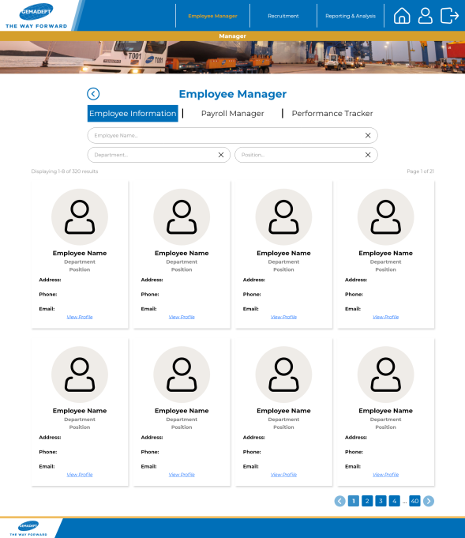

*Employee Management Window (Manager View)*

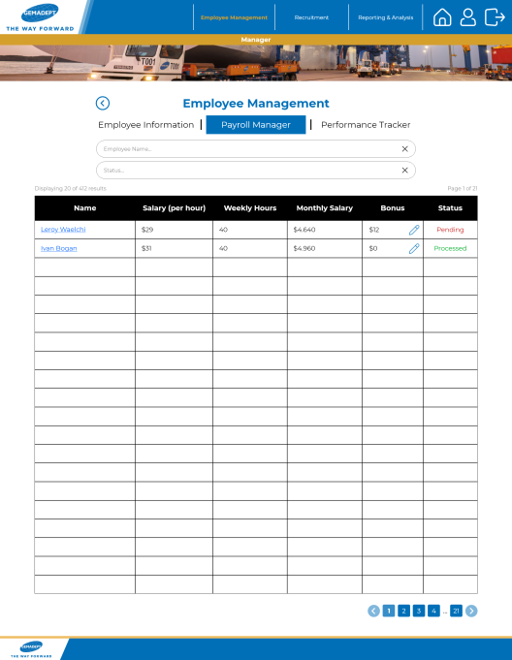

*Payroll Management Window (Manager View)*

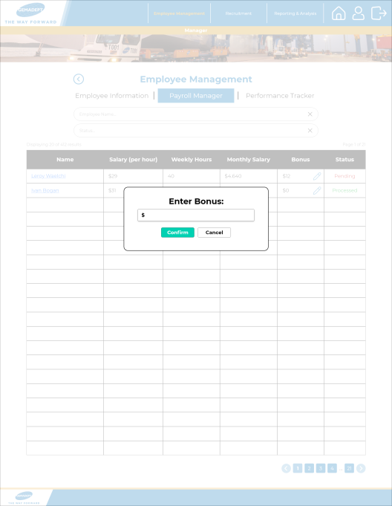

*Bonus Editing Window (Manager View)*